ASSIGNMENT-4

DISTANCE DETECTION USING ULTRASONIC SENSOR

|  |  |
| --- | --- |
| Date | 20 October 2022 |
| Team ID | PNT2022TMID43472 |
| Name | K.SAMYUKTHA PRITHYANKARA |
| Student Roll Number | 720319106019 |
| Maximum Marks | 2 Marks |

# Question1 :

Write code and connections in wokwi for ultrasonic sensor. Whenever distance is less than 100 cms send "alert" to IBM cloud and display in device recent events.

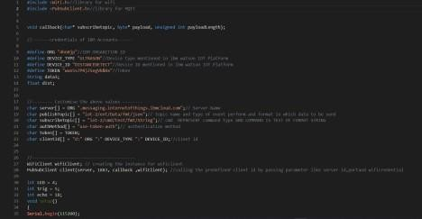CODE :

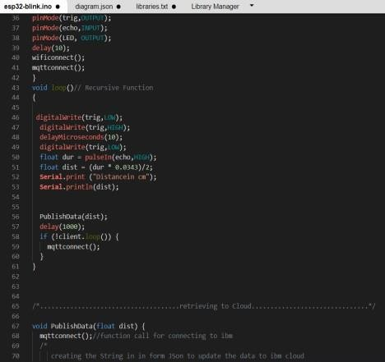

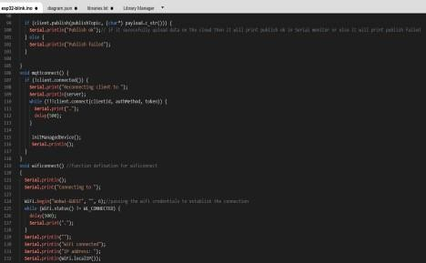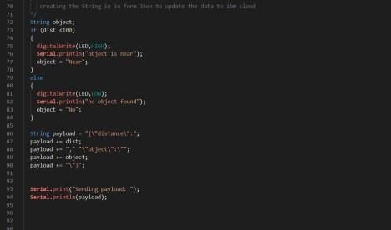

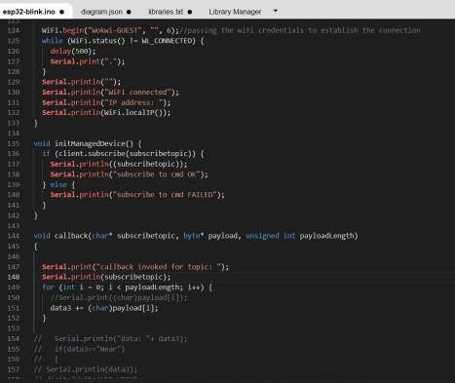

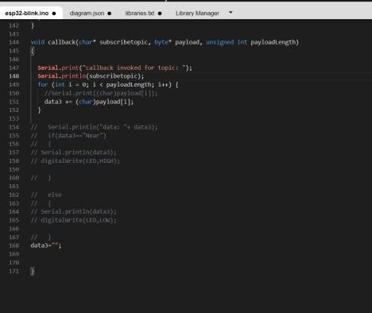

# OUTPUT:

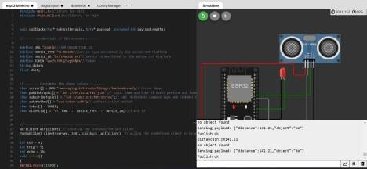

Data send to the IBM cloud device when the object is far

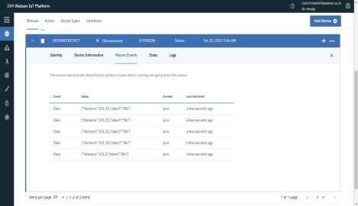

# When object is near to the ultrasonic sensor

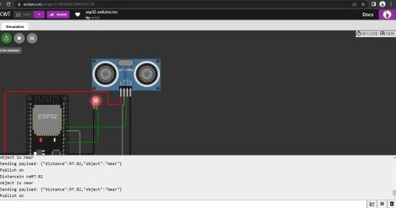

Data sent to the IBM Cloud Device when the object is near



 